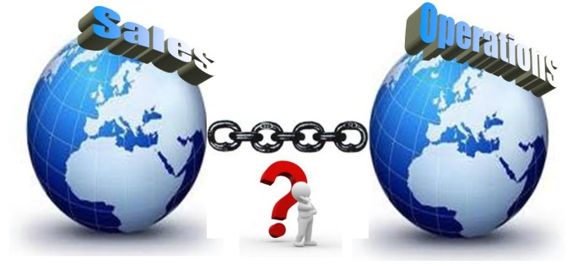
Wednesday, February 8th
Greater NJ APICS presents:

Is S&OP Part of Your Supply Chain?
… You Bet It Is!!
Anthony Zampello, CPIM, CIRM, CSCP

The full supply chain of a company must start with a strategy and a high-level plan. It must then be dropped down to each subsequent level for tactical and operational plans to support the strategy. As it drops each level, it involves more detail with a shorter horizon. This presentation will show attendees the connection and relevance of each facet of the supply chain from strategy to planning to execution closing the loop back to strategy. It will cover how demand planning varies depending on the purpose and horizon. It will cover how resource planning varies from very few, high level-long lead time areas down to the execution on the shop floor [whether your own or your producer. It will show how inventory, planned properly, is a valuable resource and minimize its risk.

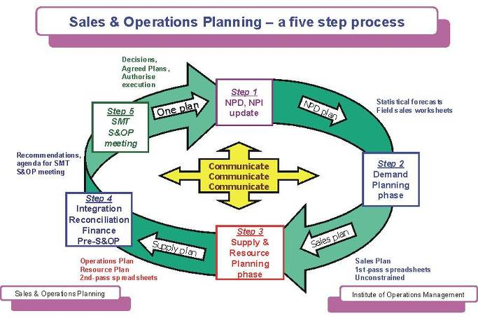
What you will learn:
- A better understanding of the FULL supply chain.
- See clearly the separation between S&OP and Master Scheduling
- A better understand resource planning at multiple levels

Who should attend?
- Entrepreneurs, Business Owners
- Students and job seekers
- Supply Chain & Operations Professionals

Cucina Calandra’s / Best Western Executive Inn
216 Rt. 46, East, Fairfield, NJ (973) 575-7720

5:30 – 6:25 Registration & Networking – Complementary Beer & Wine
6:25 – 6:35 Presidents’ Welcome & Chapter Business
6:40 – 7:30 Buffet Dinner & Discussion
7:30 – 8:30 Presentation – Q&A

Admission: $40 Full-Time Students: $20 Register at: www.apicsgnj.org
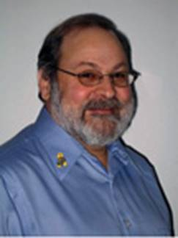
Following a long career in manufacturing and materials management, Tony now serves as a consultant, educator, and trainer to the operations and materials management profession across many industries. He's been involved for 40+ years in a broad range of industries, product types, and market environments. He has held senior management positions with Engelhard, Hasbro, Swarovski Jewelry, Wm. E. Wright, Robert Allen Design and Schroff, and has consulted with, Rolls Royce, Avon, Rockwell, DTC Communications, Plexus, Axsys, Arris, AstraZeneca, Green Mountain Coffee Roasters and Tiffany among others.
Tony has managed a wide range of initiatives, including: S&OP and ERP implementations, lead time reduction projects, offshore sourcing efforts, reorganization of materials management organizations, and inventory reduction programs. His years of experience give him a broad perspective in his consulting and teaching work in the U. S., Mexico, United Arab Emirates, The Netherlands, China and Great Britain.
He has held various leadership positions in APICS, including: Northeast District Director, VP Region 1, and President of the Providence, New Bedford and Monadnock Chapters. In addition, Tony teaches as an adjunct professor at the Worcester Polytechnic Institute, Bentley University and Fox Valley Technical College. He is currently a member of the APICS Courseware Review Committee and a member of the CPIM Reconfiguration Committee helping create the on-line learning system. He is a proud supporter of the Wounded Warriors Project.

